Experiment 3: File Recovery and Metadata Extraction
Sitabuldi Forensic Case — Assignment 3.3
Name: Sujal Wasnik UID: 23015036 Hostname: [FILL IN]

1. Hash Verification (Both Images)
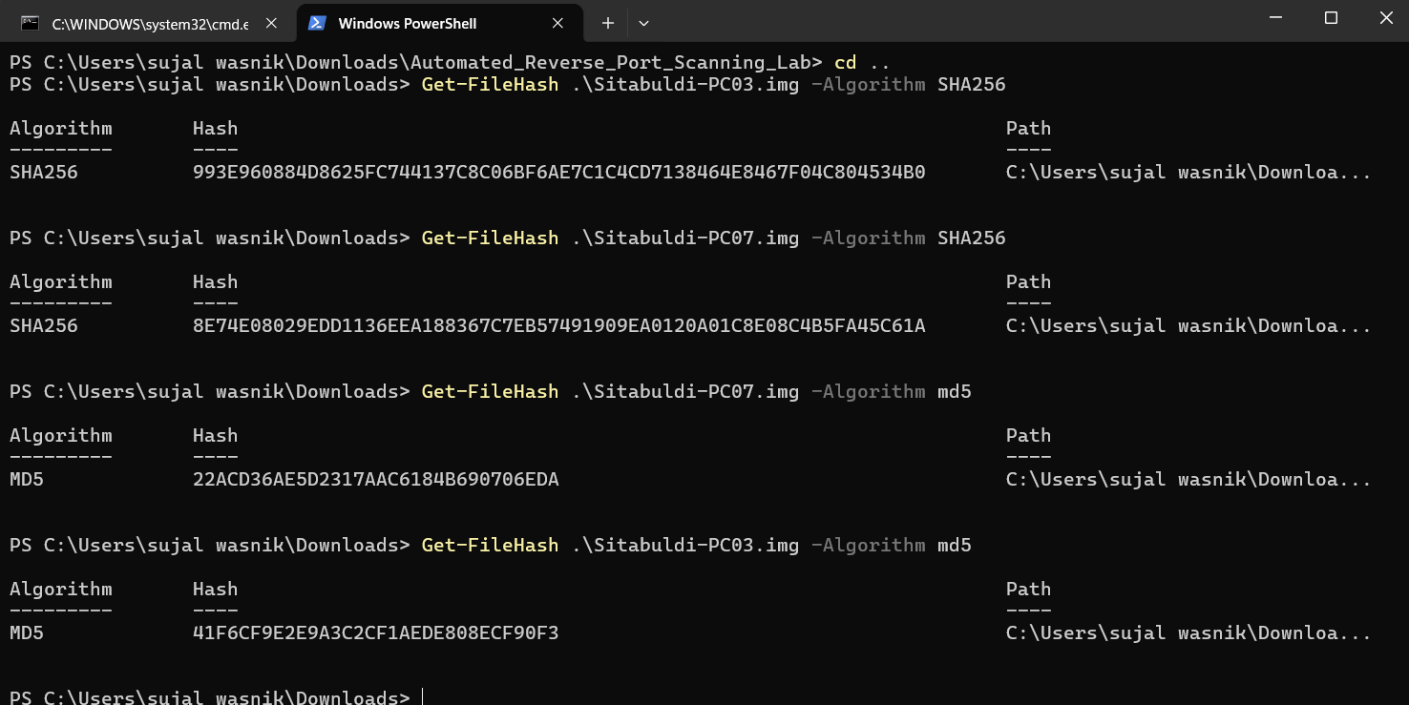
PowerShell Get-FileHash output for Sitabuldi-PC03.img and Sitabuldi-PC07.img (SHA-256 and MD5).
First thing I did, before opening either image in Autopsy, was hash both of them using Get-FileHash in PowerShell (SHA-256 and MD5). I do this before any analysis because it locks in what the file looked like at the very start — if someone re-hashes the image later and gets a different value, that's proof it was touched. Skipping this step would make it impossible to argue the evidence wasn't tampered with during analysis.

2. Deleted File Recovery
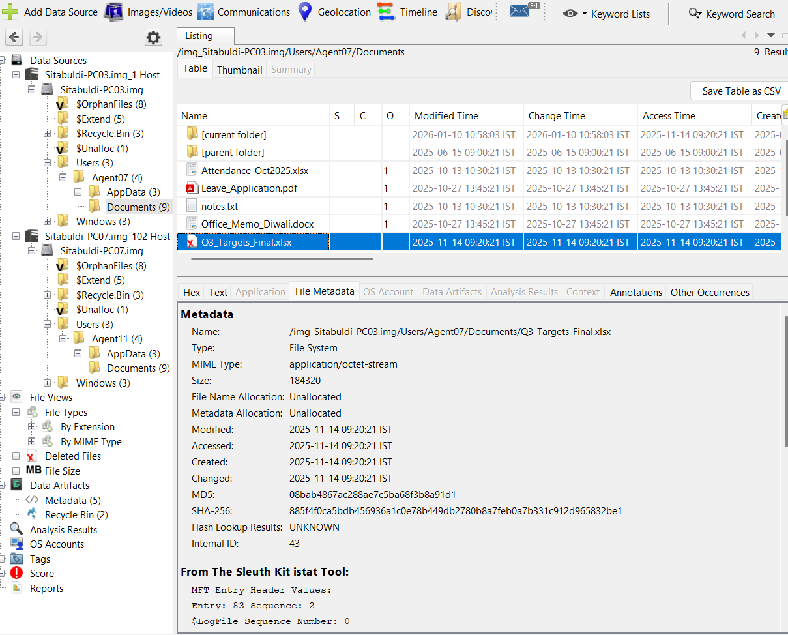
Autopsy listing + File Metadata/istat panel for Q3_Targets_Final.xlsx recovered from C:\Users\Agent07\Documents on Sitabuldi-PC03.img.
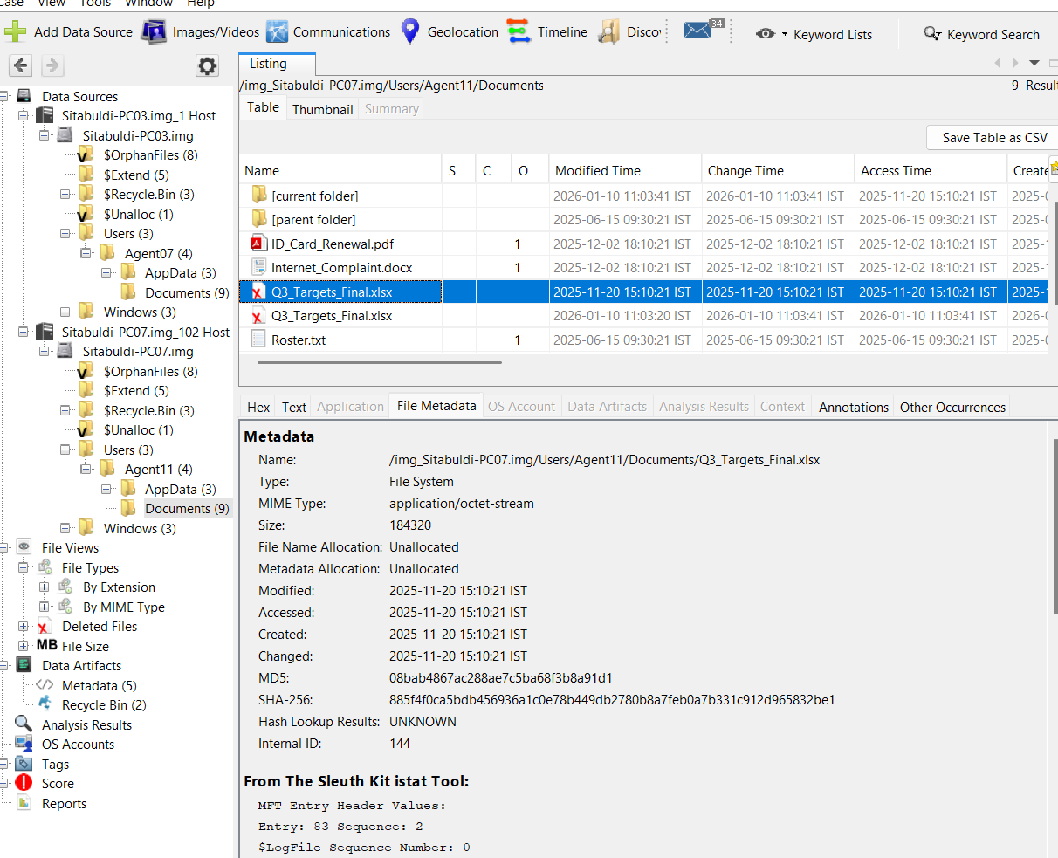
Autopsy listing + File Metadata/istat panel for Q3_Targets_Final.xlsx recovered from C:\Users\Agent11\Documents on Sitabuldi-PC07.img.
Went through Deleted Files in Autopsy for both images and found the same thing on each: a file called Q3_Targets_Final.xlsx sitting in the Documents folder, marked unallocated (Agent07's on PC03, Agent11's on PC07). Same size too, 184,320 bytes on both. That's the part that stood out to me — it's not just that both agents had a similarly-named file, it's the exact same file in the exact same location on both machines, which means this was pushed to both of them and then deleted afterward on both, not something one agent made independently.

3. File Investigation and Repair
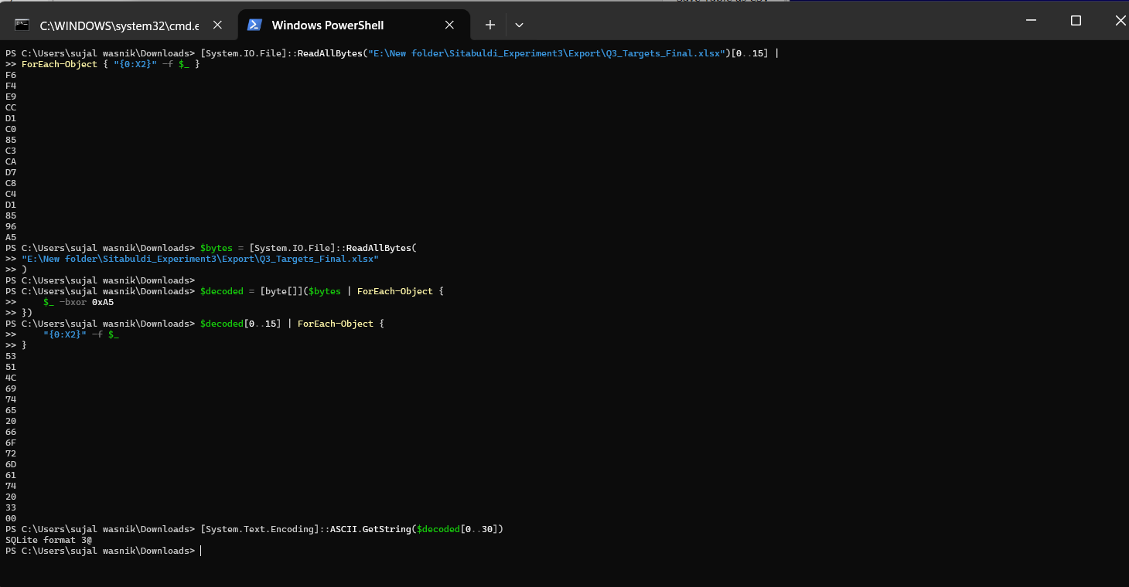
PowerShell hex dump of the recovered file's leading bytes, followed by an XOR 0xA5 decode revealing the SQLite header.
This is the part that took the longest to figure out. A real .xlsx is a ZIP file, so it should start with PK, but when I dumped the first bytes I got F6 F4 E9 CC D1 C0 85 C3 CA D7 C8 C4 D1 85 96 A5 — nothing close to a ZIP header. I noticed 0xA5 kept showing up a lot more than it should if this were random data, so I tried a single-byte XOR against 0xA5 just to test it. Ran it in PowerShell, converted the decoded bytes to ASCII, and got 'SQLite format 3' right at the start. So the .xlsx extension was fake the whole time — someone had taken a SQLite database, XORed it with 0xA5, and renamed it to look like a spreadsheet.

4. Recovered Data
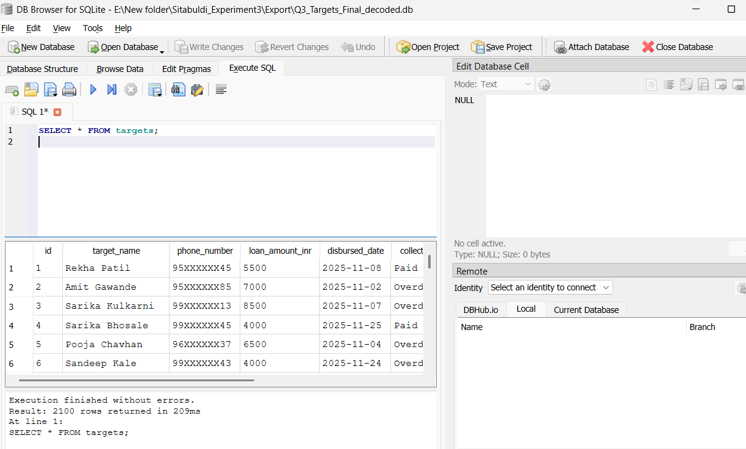
SELECT * FROM targets; — full column list, 2,100 rows returned.
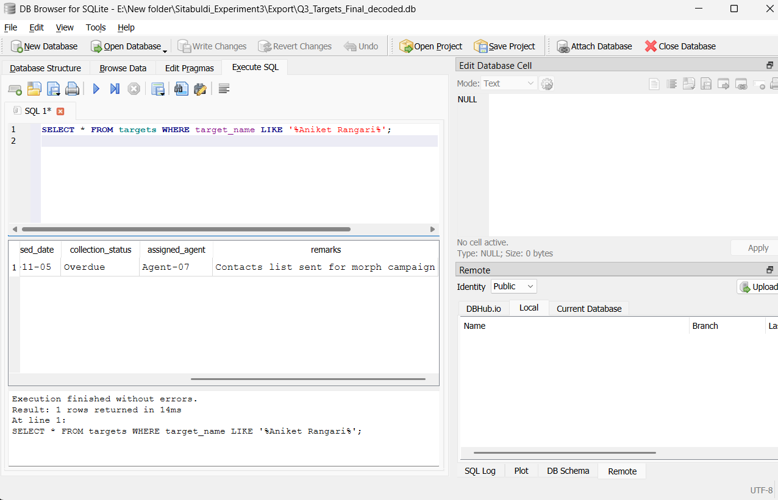
Query result for target_name LIKE '%Aniket%' OR '%Rangari%', showing the Overdue status, Agent-07 assignment, and 'morph campaign' remark.
Once I had the decoded file opened in DB Browser, running SELECT * FROM targets; showed a table with columns for target_name, phone_number, loan_amount_inr, disbursed_date, collection_status, assigned_agent, and remarks, and 2,100 rows total — same number as the TotalRecords value I found later in the properties table, so that checks out. I searched for Aniket/Rangari specifically because that name came up in the earlier experiments, and it's in here: status Overdue, assigned_agent Agent-07, and the remarks field literally says 'Contacts list sent for morph campaign.' That's a real, specific link back to what we found in Experiment 1/2, not just a coincidence of similar data.

5. Internal File Properties
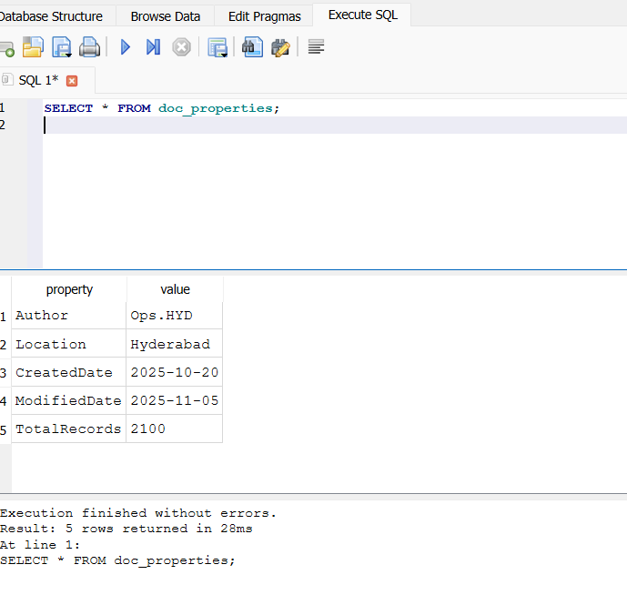
SELECT * FROM doc_properties; — Author = Ops.HYD, Location = Hyderabad, TotalRecords = 2100.
There's a second table in the database, doc_properties, that stores its own metadata: Author = Ops.HYD, Location = Hyderabad, CreatedDate = 2025-10-20, ModifiedDate = 2025-11-05, TotalRecords = 2100. This is the inconsistency I mentioned earlier — we recovered this file from two Sitabuldi machines, but the file itself is saying it was made in Hyderabad by someone/something called Ops.HYD. Neither agent's machine is in Hyderabad, so my read on this is that the file wasn't created locally by either agent — it was built somewhere in Hyderabad and then handed off to both of them.

6. Hash Comparison
Went back to the File Metadata panel for both recovered files to compare hashes directly. PC03's copy (Section 2, first screenshot) gives MD5 08bab4867ac288ae7c5ba68f3b8a91d1 and SHA-256 885f4f0ca5bdb456936a1c0e78b449db2780b8a7feb0a7b331c912d965832be1. PC07's copy (second screenshot) gives the exact same MD5 and SHA-256. Since both algorithms match perfectly, this isn't just "two files with the same name" — it's literally the same file, bit for bit, on both machines. That basically rules out the possibility that Agent07 and Agent11 each built their own version independently.

7. Section 63(4)(c) Certificates
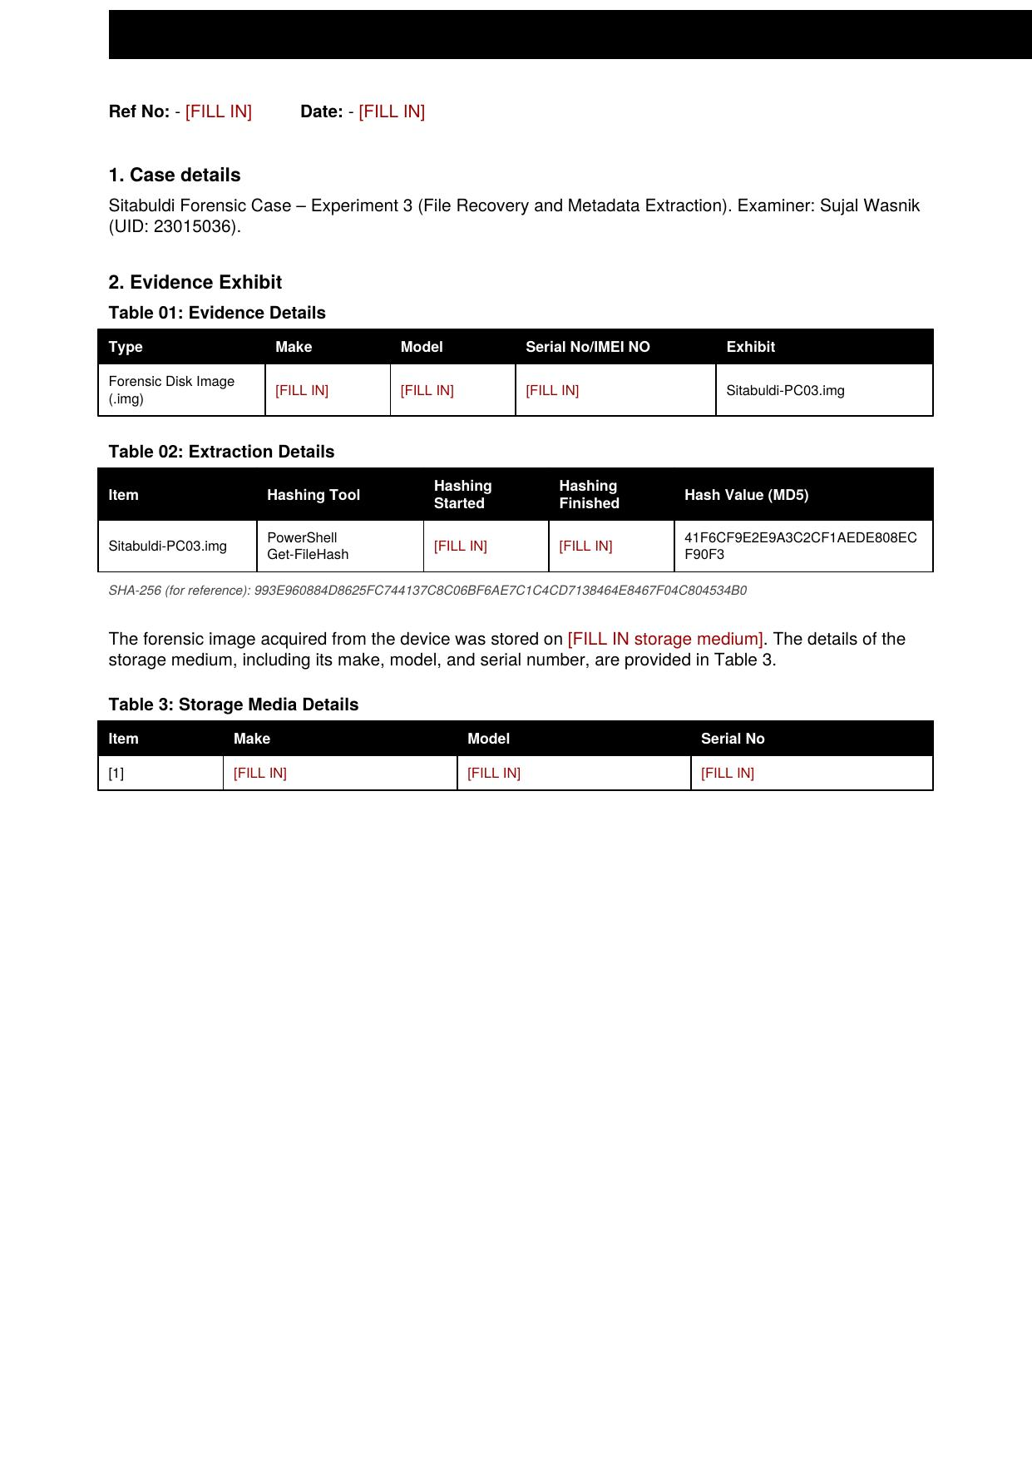
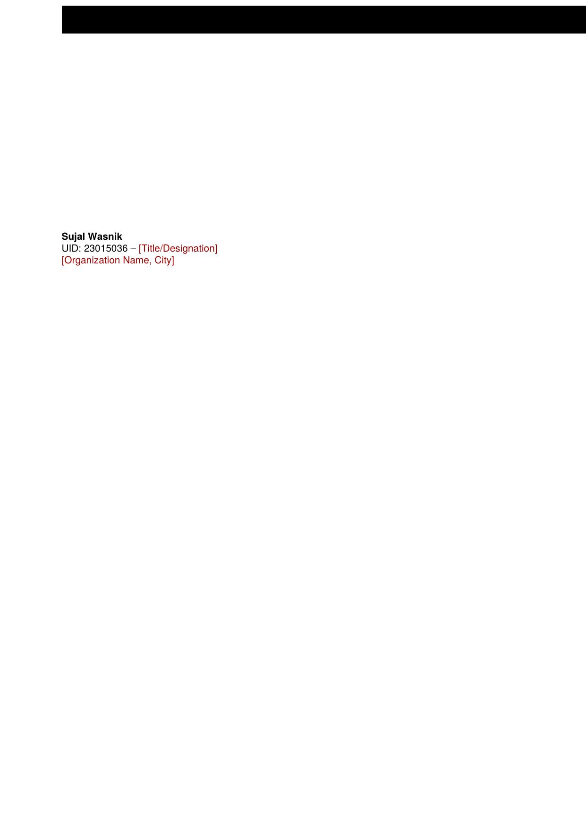
Section 63(4)(c) certificate for Sitabuldi-PC03.img.
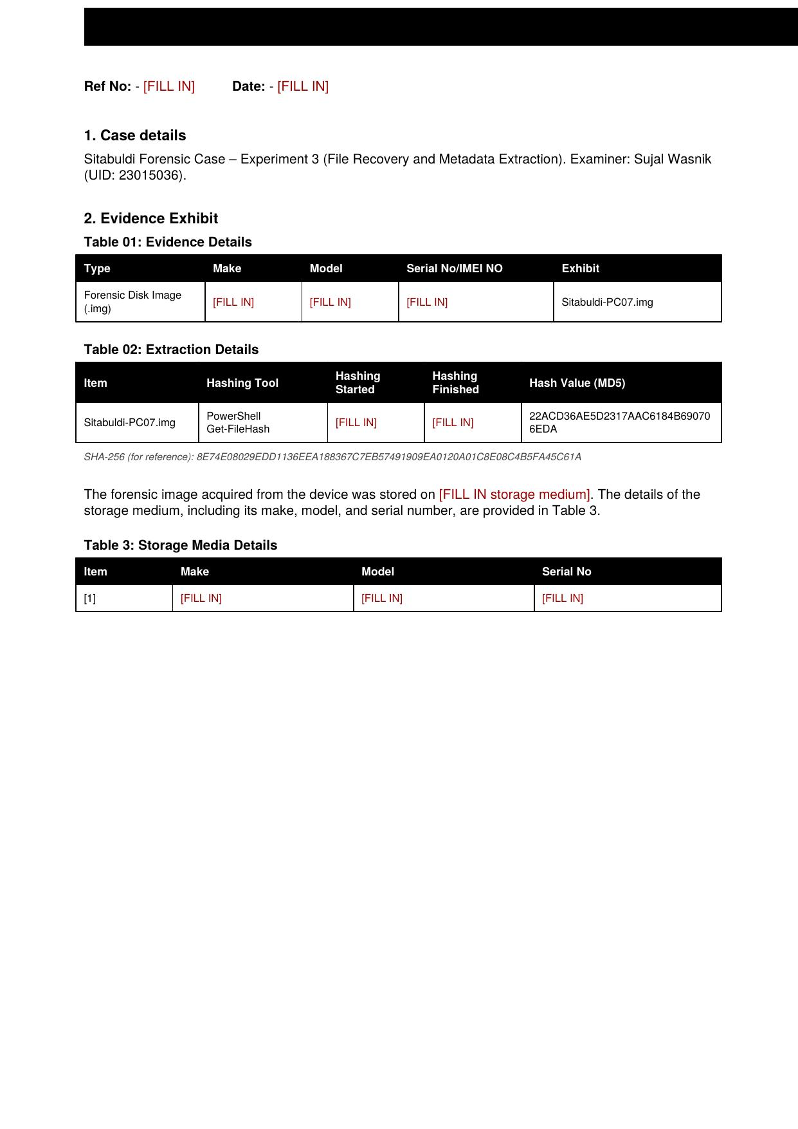
Section 63(4)(c) certificate for Sitabuldi-PC07.img.
(Filled in the hash values, exhibit names, and my details from this experiment — still need to add the ref no., date, storage medium/serial info, and designation/organization from the earlier experiments before this is final.)

. Summary — Connecting the Findings
Putting it all together: the same disguised database, with the same 2,100-record target list, was on both Agent07's machine (PC03) and Agent11's machine (PC07), and the recovered copies hash identically, so it's the same file, not two similar ones. The file's own metadata says it came from Hyderabad ('Ops.HYD'), not from either Sitabuldi machine, which lines up with the idea that this target list was put together centrally and then pushed out to both agents before being deleted on both ends. And the Aniket Rangari / Agent-07 / 'morph campaign' entry inside the data is what actually connects this file back to the agent-level activity we were already looking at in Experiments 1 and 2 — it's not a separate thread, it's the same operation.

